**Each and every point is valuable one**

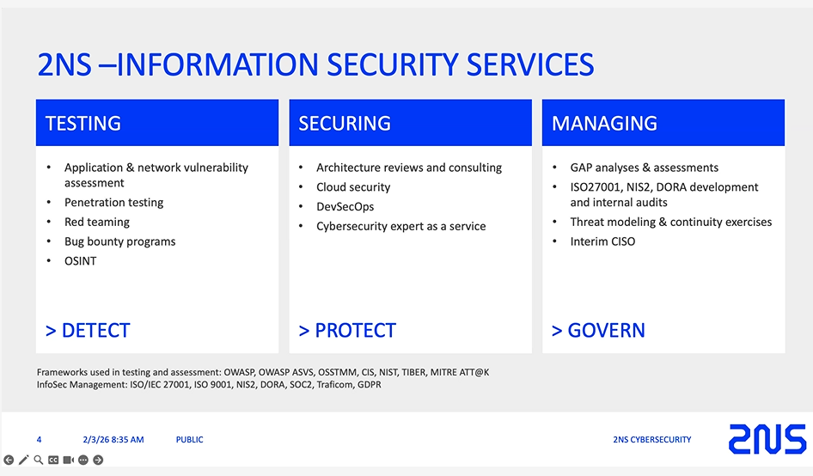

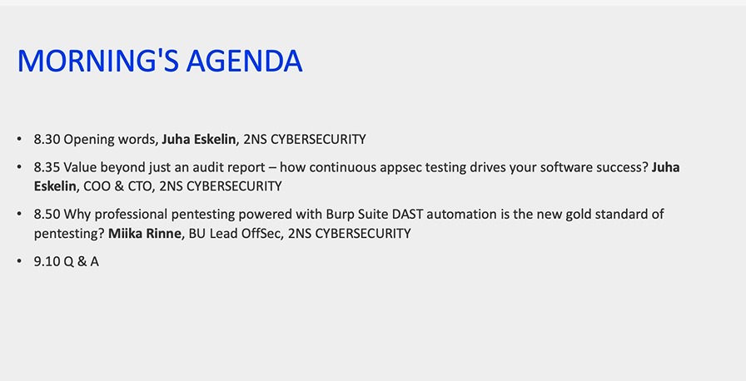

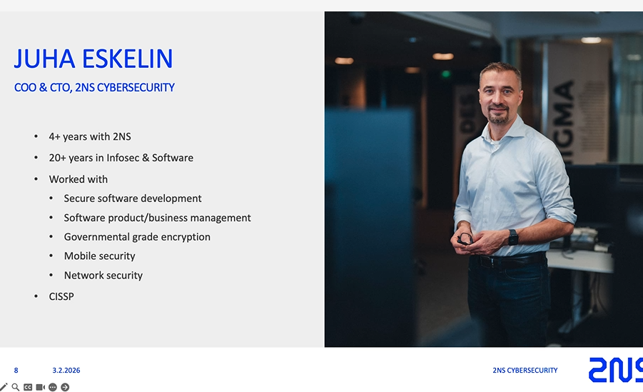

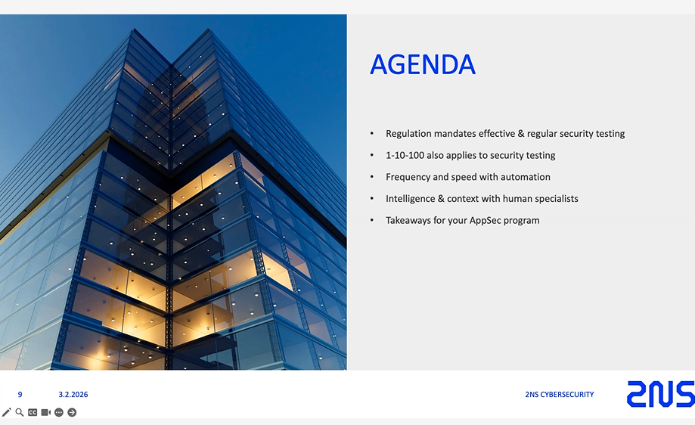

Benefits of continuous security testing

Reflection on last year

- intesnse wth regulation - regulatory Tsunami - EU reglatory change

DORA and CYber resilience act

Will start in September 6 or sevenmonths time

Affect products with digital element

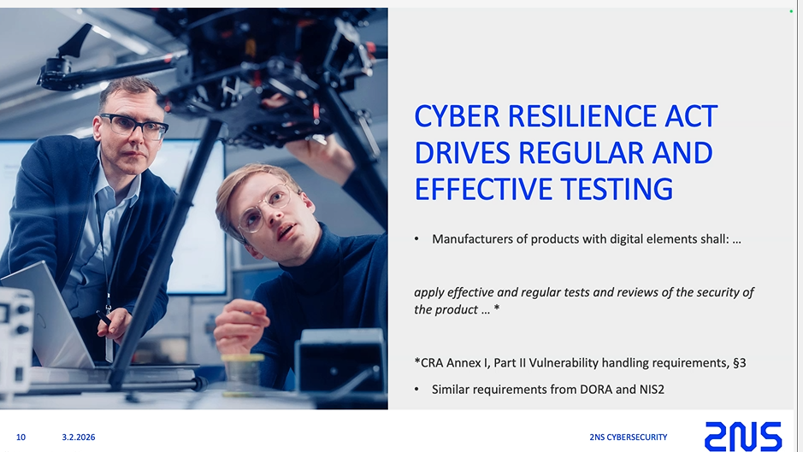

CRA category - DORA and Cyber resilience will have effect on software companies

CRA Annex Part II Vulnerability handlung Requirements

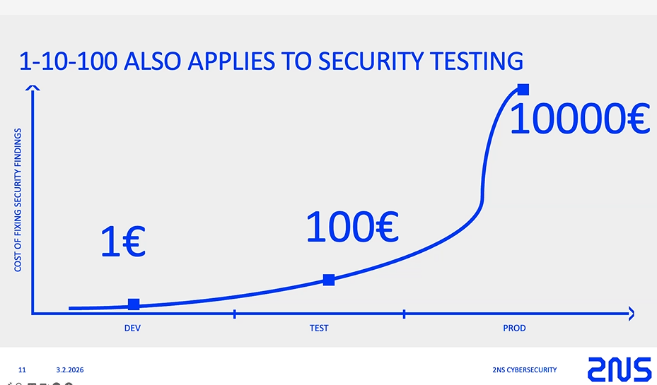

Quality Rule - 1-10-100

If the vuln reaches an application at Prod as un authenticatef attackert - then cost for loss is 10s and thousands of amount

**SHIFT LEFT -** How fixing sec bugs in Dev side is much less expensive than finding it at final stage

Integrated security Testing Process

Scanners - SAST and DAST

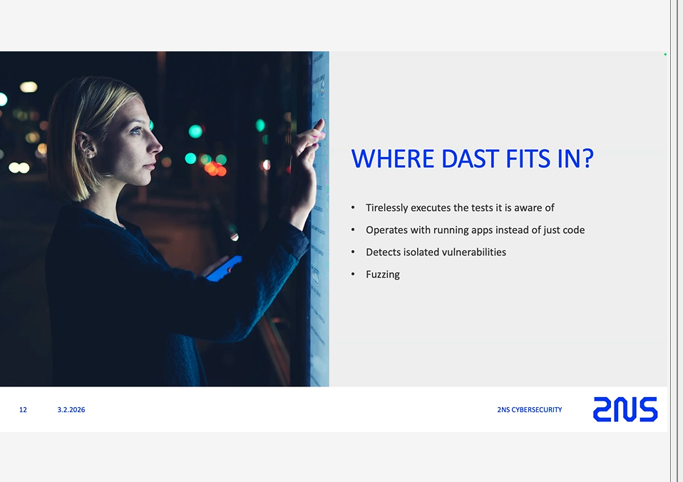

**Zalaris Penetration :** Create a integrated CI CD Tool that surpasses the weak-spots that are available in the 2NS Process

Integrate SAST and DAST together

This is a simple process just needs some time - and can be done !!!!!!!!!!!!!!

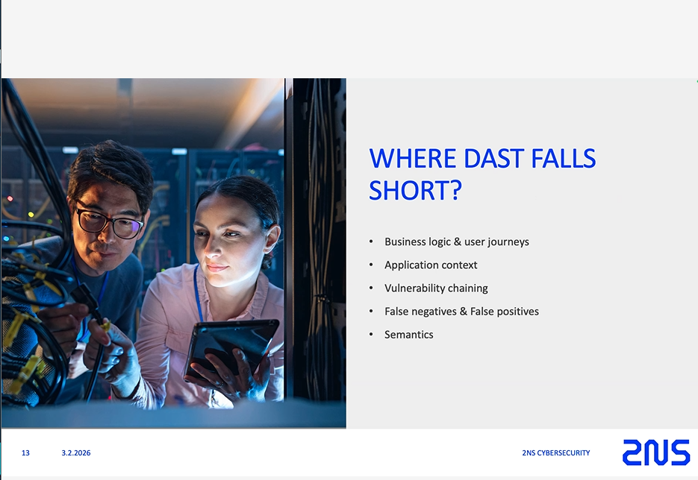

Where SAST and DAST falls short - Manual Penetration test ensures security

SAST + DAST + Manual Penetration tester - PTAAS [Will always be the golden model not just for now]

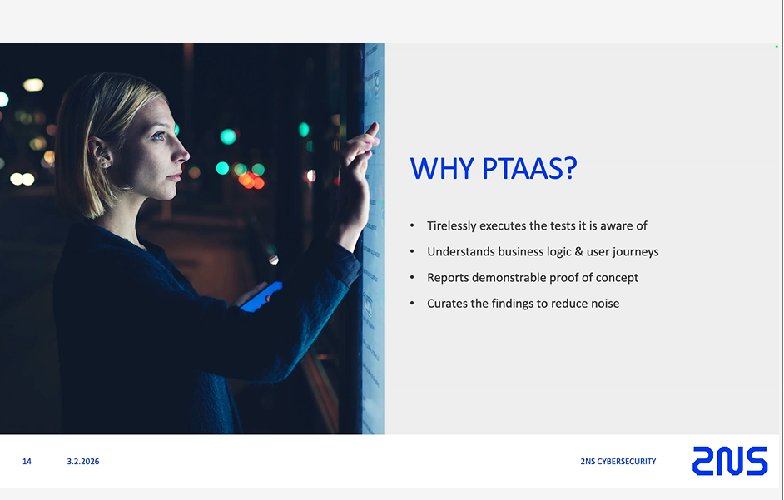

**Edge Test Cases**

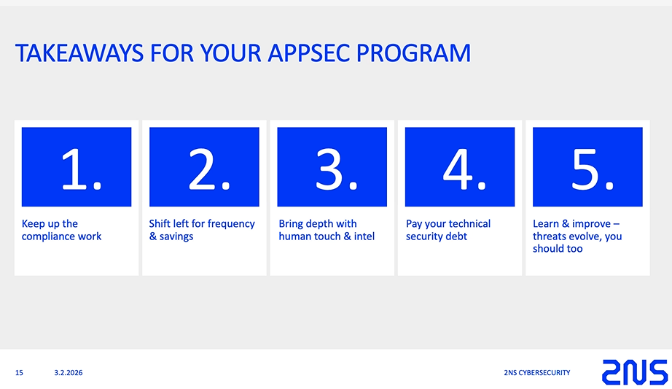

Process with Devs , managers and management

1-10-100

**JUHA Ends Topic**

**Mika Renne**

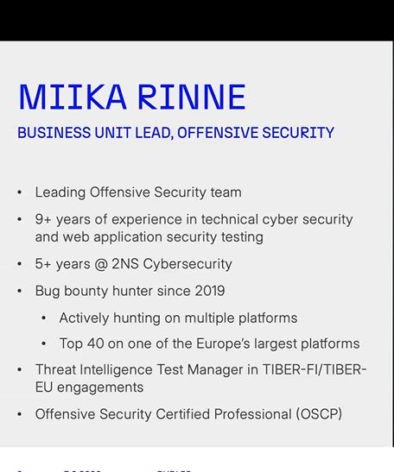

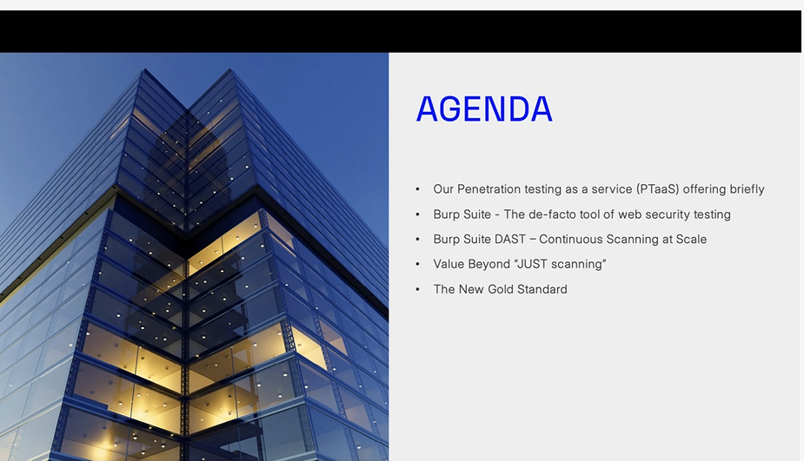

**PTAAS Offering**

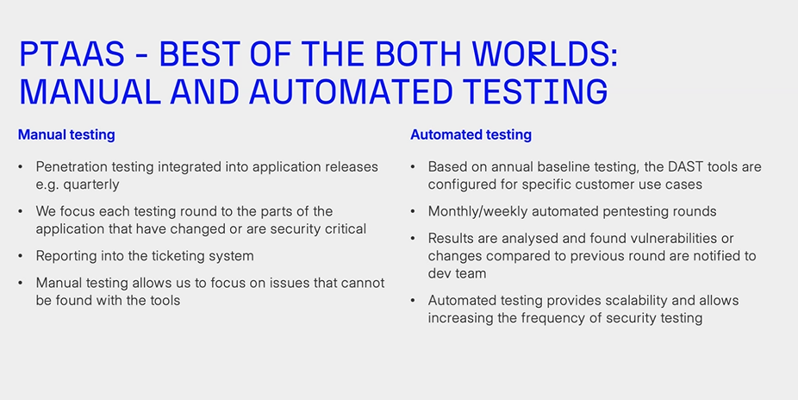

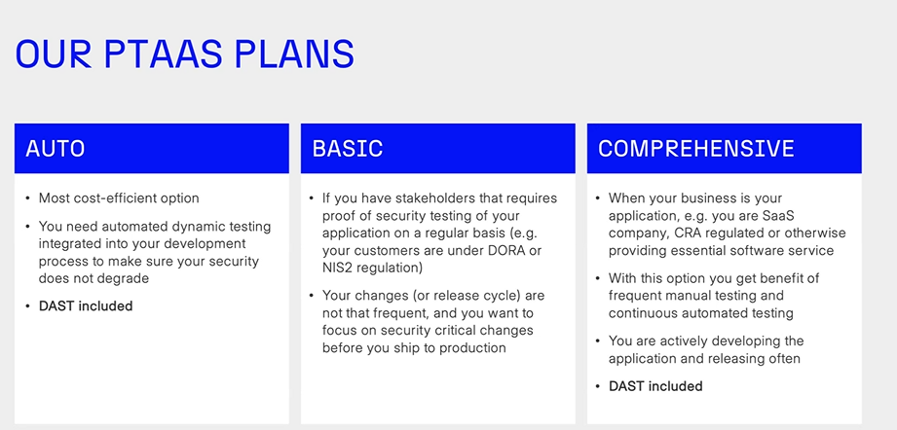

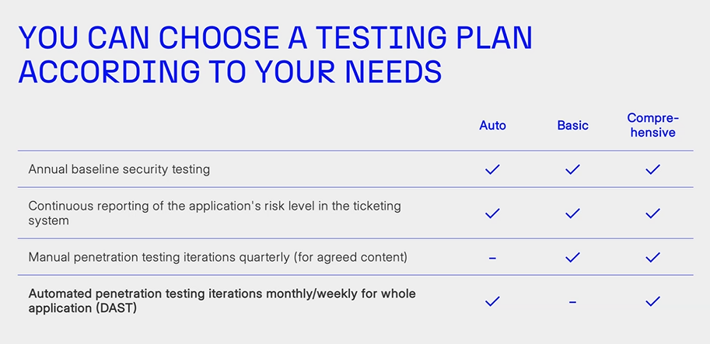

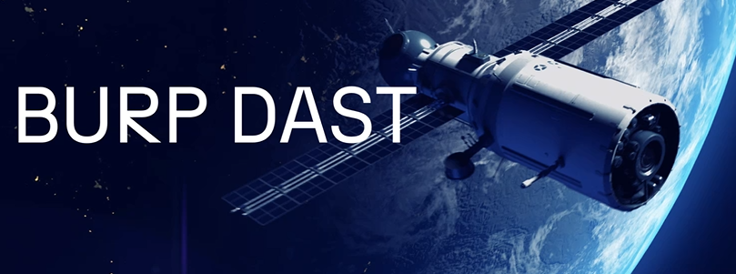

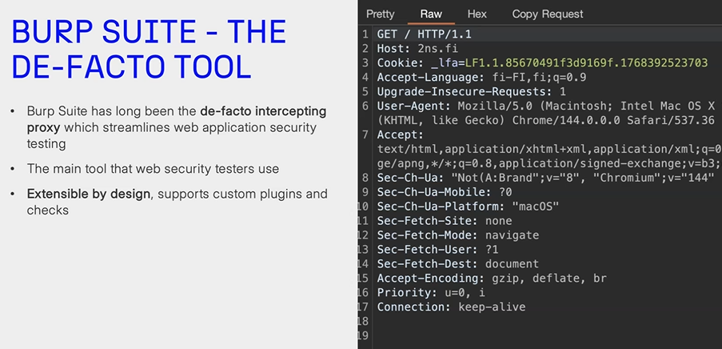

**Just a normal discussion on BURP - the important one**

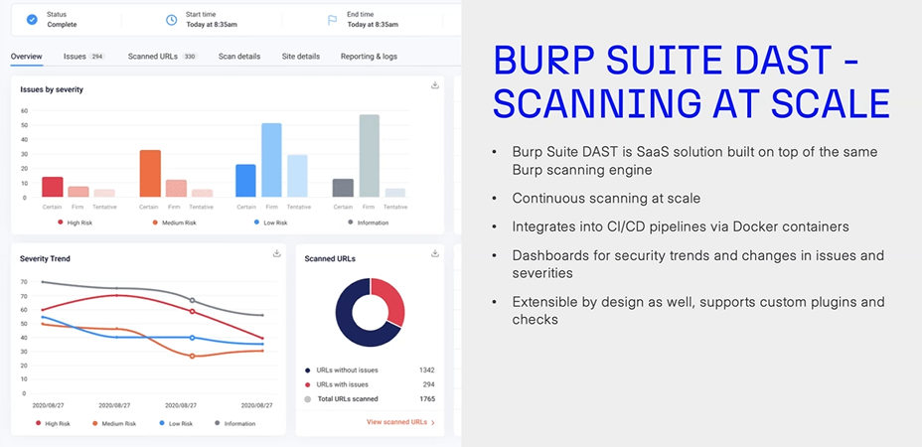

This Dashboard is different form OURS - why ?? I s this a different commercial licensed ??

Scanning engine is extensible by design

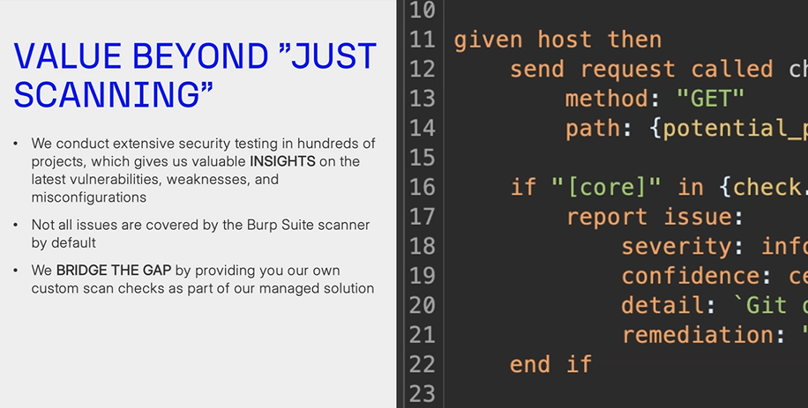

Not all the issues are still covered by BURP but Is still extensible

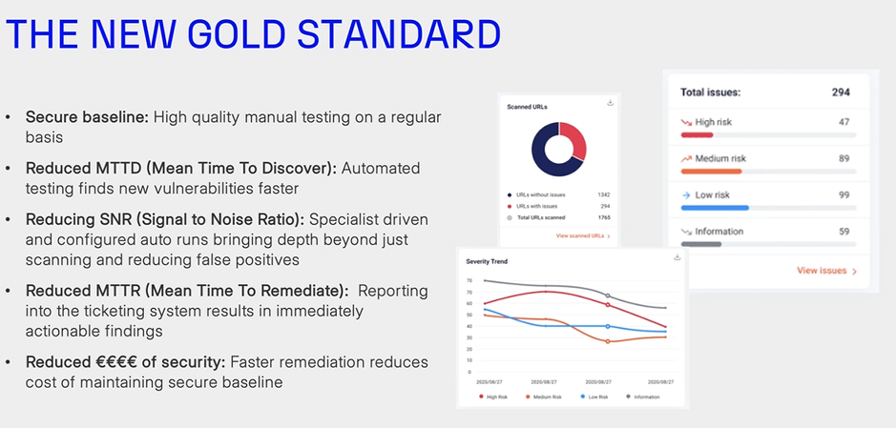

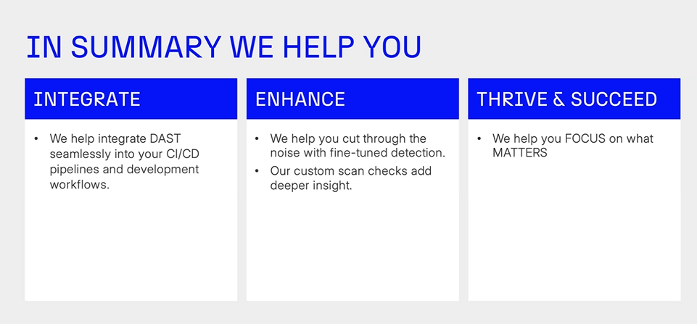

The process explained by 2NS is simple and we can replicate this and improve on the same

PTAAS Integrating the

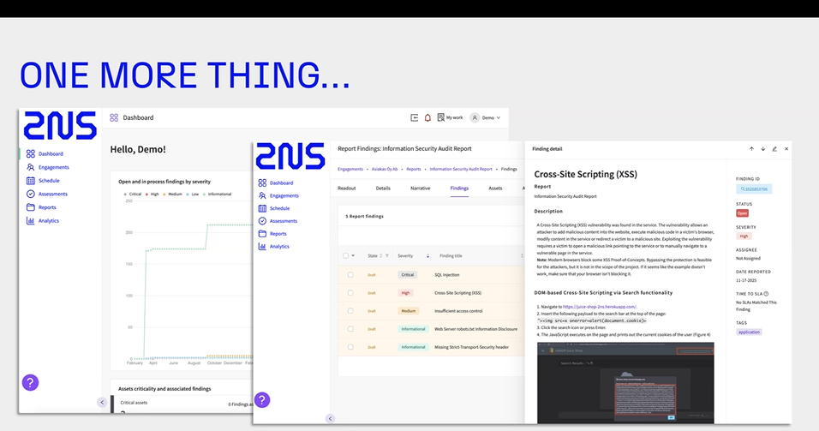

The process by 2NS can be overtaken and can be improved

- what are the short falls in their process ?

We need a full suite for the we need a powerful machine - we can use the CSOC remote serve but will need **more Juice - more RAM , More availability and Resilience**